Smart Dustbin

Description:
The Smart Dustbin is an automatic waste bin that opens its lid when a person brings their hand close to it. An ultrasonic sensor detects the presence of an object near the bin. The Arduino processes the sensor data and controls a servo motor to open the lid automatically. After a few seconds, the lid closes again. This project helps maintain hygiene and reduces the need to touch the dustbin manually.
Block Diagram:
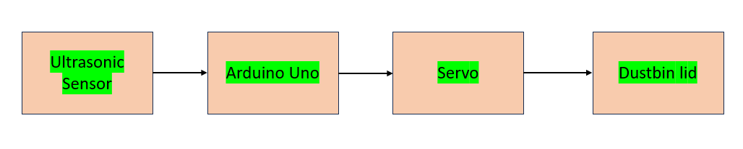
Pinout / Circuit Connection:
Ultrasonic Sensor (HC-SR04) → Arduino
Ultrasonic Pin | Arduino
VCC | 5V
GND | GND
TRIG | D9
ECHO | D10
Servo Motor → Arduino
Servo Wire | Arduino
Red | 5V
Brown/Black | GND
Orange/Yellow (Signal) | D6

Components Required:
- Arduino UNO
- Ultrasonic Sensor (HC-SR04)
- Servo Motor (SG90)
- Cup or small container (used as dustbin)
- Jumper wires
- Breadboard
- Power supply / USB cable
Working Principle:
The ultrasonic sensor measures the distance between the sensor and any nearby object by sending ultrasonic waves and receiving the reflected signal. When a hand is placed near the bin, the sensor detects a short distance. Arduino then sends a signal to the servo motor to rotate and open the lid. After a few seconds, the servo rotates back and closes the lid automatically.
Operation (Step-by-Step):
- Power ON the Arduino system.
- The ultrasonic sensor continuously measures the distance.
- When a hand or object comes within a set distance (for example 15 cm), the sensor sends the data to Arduino.
- Arduino processes the signal and rotates the servo motor to open the dustbin lid.
- After a short delay, the servo motor rotates back to close the lid.
Arduino Code:
#include <Servo.h>

#define trigPin 9
#define echoPin 10

Servo myServo;

void setup() {
pinMode(trigPin, OUTPUT);
pinMode(echoPin, INPUT);
myServo.attach(6);
Serial.begin(9600);
}

void loop() {

long duration;
int distance;

digitalWrite(trigPin, LOW);
delayMicroseconds(2);

digitalWrite(trigPin, HIGH);
delayMicroseconds(10);
digitalWrite(trigPin, LOW);

duration = pulseIn(echoPin, HIGH);
distance = duration * 0.034 / 2;

Serial.print("Distance: ");
Serial.println(distance);

if (distance <= 15) {
myServo.write(90); // open lid
delay(3000);
} else {
myServo.write(0); // close lid
}

delay(500);
}
Conclusion:
The Smart Dustbin is an efficient and hygienic waste management system that automatically opens the lid when a person approaches. It demonstrates the use of ultrasonic sensors and servo motors for automation, making it a practical application of embedded electronics.
References:
- Arduino Project Hub – Smart Dustbin using Ultrasonic Sensor.
- Electronics Tutorials – Servo Motor Interfacing with Arduino.

